## horizontal line



Assignment # 2

**Course Allocation System -** Case Study # 1

**─**

**CS322 - SC - Software Construction**

**Group 1 - Team Members:**

1. Ali bin Qadeer ( Team Lead ) - 04072113033
2. Zakir Matloob - 0407213055
3. Basid Ali - 04072113012

**Submission Date:** 09-10-2023 09:00 AM

**Table of contents**

1. Use-case Diagram…………………………………………………………….…………………...……………………………………………..02
2. Special Requirements…………………………………………...……………...……………………………………………….……………...03
3. Use-case Text………………………………………………………………………………………………...………………………………...….04
   1. Use-case # 1 ……………………………………………………………………………………………………………….…….….05
   2. Use-case # 2 ……………………………………………………..………………………………………………………….…….…08
   3. Use-case # 3 ………………………………………………………………………………..………………………………………..11

**Course Allocation System**

1. **Use-case Diagram :**

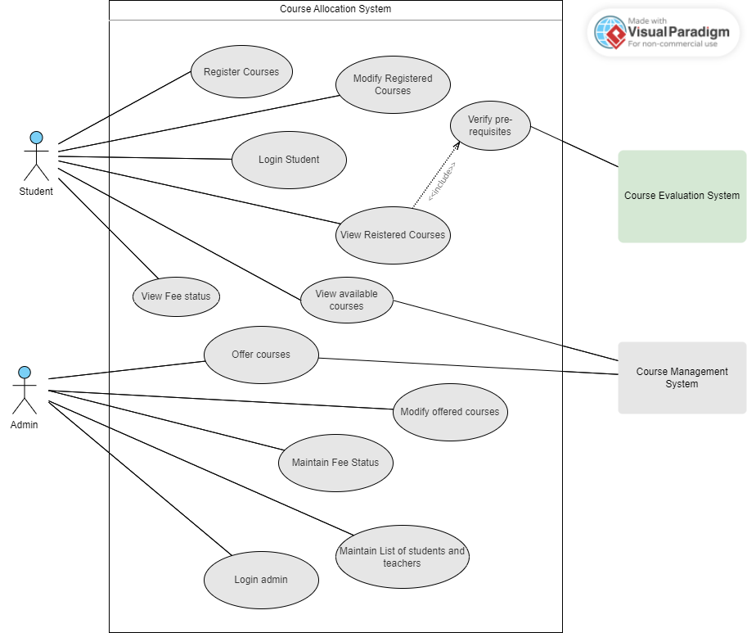

1. **Special Features:**

The features that would make our software unique and worth using are as follows:

* **Varied User Roles:** The system caters to different user roles, including students, teachers, and administrators, each with specific needs and responsibilities. This diversity of user roles necessitates role-based access control
* **Prerequisite Management:** The system needs to check and validate course prerequisites, ensuring that students can only register for courses they are eligible for.
* **Scalability:** As there are plans to extend the system to multiple university departments, scalability is a significant consideration. The system should be able to accommodate a growing number of students and courses.
* **Data Privacy Compliance:** The system must comply with data privacy regulations and protect the security and privacy of student and teacher data.
* **Fee Payment Verification:** An essential feature involves verifying that students have paid their fees for the current semester before allowing course registration.
* **Accessibility**: the accounts will be accessible anywhere and anytime within the department boundaries on the university internet.

1. **Use-case Text :**
2. **First Use-case Text ( Zakir Matloob 04072113055 )**

**USE-CASE # 1: offer courses**

1. **Primary Actor:**

* Administrator.

1. **Stakeholders and Interests:**

* **Student :**

Students have to register for the courses being offered by the admin.

* **Admin :**

Admin offers courses each semester.

* **Teacher :**

Teachers have the information of the course being assigned to her/him.

* **Course Management System :**

This system will store and provide information about courses that can be offered.

* **Course Evaluation System :**

This System provides **each student's Pass / Fail course information** for pre-requisite clearance to register for courses.

1. **Pre-condition:**

The administrator must be the registered employee of the Computer Science with proper access rights.

1. **Post-conditions:**

All the courses are accurately specified, and saved in the system made available for student registration.

1. **Main-success scenario:**
2. The administrator logs into the system.
3. The system verifies the credentials and displays the interface for the admin.
4. The administrator selects the “Create New Course” or “Modify Course” option.
5. The administrator provides course details, including course names, descriptions, prerequisites, credit hours, and assigned teachers for each course.
6. The administrator sets the status for the courses ( Open, Closed, to be opened, etc.) for registration.
7. The administrator saves the details.
8. The system adds the course to the course offering.
9. The administrator will repeat the steps 3-7 for each course to be either offered or modified.
10. Once all courses are added or modified, the administrator selects the “Publish courses” option.
11. The system makes the course available for the student registration.
12. **Alternative Flow ( Extensions ):**
    1. At any time system fails:

To support recovery from any step of scenario:

1. Admin restarts system, logs in, and requests recovery of prior data.
2. The system reconstructs prior data.
   1. The system detects anomalies preventing recovery:
      1. The system signals the error to the admin, records the error, and enters a clean state.
      2. Admin refreshes the web-page and logs in again and starts from scratch.
3. Admin enters wrong credentials while logging in:
   1. **Invalid ID:**
      1. The system signals an error and rejects the entry.
   2. **Invalid password:**
      1. The system signals an error rejects entry and gets alerted if someone else, is trying to get into the system.

4. The administrator entered the wrong information about the course :

- If the admin had mistakenly entered wrong information, there is a modify option, where he can make any type of correction which will be updated and the student will be notified about that update. If the admin misses any information before publishing the course offering an alert message appears on the interface to enter all the mandatory details.

1. **Special Requirements:**

* Only registered admin employees of the department can log in to the system to offer courses.
* The account can be accessed only on the university internet.
* Auto-saving feature while entering course details.
* Courses with different status labels ( open, closed) to identify their status.

1. **Technology and Data Variations:**

* Credentials are entered from the keyboard.

1. **Frequency of Occurrences:**

* Courses are offered only once every semester.

1. **Open Issues:**

* What if an actor wants to access the website outside the university on a different internet?

1. **Second Use-case Text ( Basid Ali 0407213012 )**

**USE-CASE # 2: register courses**

1. **Primary Actor:**

* student.

1. **Stakeholders and Interests:**

* **Student :**

Who registers for courses.

* **Admin :**

Who offer courses

* **Teacher :**

Who possesses knowledge regarding the course being taught in which semester.

* **Course Management System :**

Who provides information regarding courses offered each semester.

* **Course Evaluation System :**

This System provides **each student's Pass / Fail course information** for pre-requisite clearance to register for courses.

1. **Pre-condition:**

Students are required to log into the system using a valid ID.

1. **Post-conditions:**

The student has successfully enrolled in the courses that were made available to them.

1. **Main-success scenario:**
2. Students enter his/her registration number and password.
3. Students can see the courses that are offered.
4. Students can check the prerequisites of the courses.
5. The system displays various options like registering for courses, viewing the available courses, offered courses, etc.
6. He/she selects “register course”.
7. The system displays an option where he/she can add his course code(class code).
8. Students select the next/more option.
9. He/she can add classes/courses within constraints.
10. Students can modify registered courses .
11. The system shows selected/ added classes.
12. **Alternative Flow ( Extensions ):**

At any time system fails:

1. The request of the student is not completed.

2. System restarts and spontaneous recovery of data.

2. System restarts and spontaneous recovery of data.

1) Student enters invalid information.

a) Invalid ID/registration number:

The system signals an error and rejects the entry.

b) Invalid password:

The system signals an error to the student, records the error, and enters a clean state.

The student re-enters the password.

1. The student selects another option by mistake:
2. The system displays information related to that option.
3. The system allows students to go back to the previous state.
4. Students enter the wrong course code/class number.
5. The system displays an error if no course is found but if exists then displays information related to that course
6. The system allows students to remove errors and enter the correct course code.

8) Registration constraints:

1. The system shows an error if credit hours are extended.
2. The system shows an error if a student wants to register for a course in which the prerequisite is not passed.
3. Modify courses:

* Students can only register for courses within the time period.
* Students can drop courses within the time period.

1. **Special Requirements:**

* Course registration deadlines will be very visible and prominent.
* Only registered students can register for courses.
* Courses with different status labels ( open, closed) to identify their status.

1. **Frequency of Occurrences:**

It is permissible for an occurrence to take place multiple times within the designated time frame. However, it is imperative that access is not granted after the specified due date under any circumstances.

1. **Open Issues:**

Could not open after the due date.

1. **Third Use-case Text ( Ali bin Qadeer 04072113033 )**

**USE-CASE # 3: student login**

1. **Primary Actor:**

* Student
* Teacher
* admin

1. **Stakeholders and Interests:**

* **Student :**

Students have to log in to access his/her account to see and register for the courses.

* **Administrator :**

Administrators have to log in to access his/her account to offer courses.

* **Teacher :**

Teachers have to log in to check the courses that have been assigned to him/her.

1. **Pre-condition:**

The user is registered in the system and has valid login credentials. He/she must have good internet access and the server should not be down.

1. **Post-conditions:**

The user is successfully logged in to his/her profile and the system is now ready for him to perform any further actions.

1. **Major success scenarios:**

1. The user opens the login interface.

2. The user adds his/her login ID.

3. The user adds his/her password.

4. The system verifies the credentials.

5. The system grants access to the user’s dashboard.

1. **Alternative Flow ( Extensions ):**

At any time system fails:

1. The server stops responding:
2. Internet error:

i. The system shows an error msg.

1. Server down:

i. The system stops working due to too much traffic.

* The user enters the wrong credentials while logging in:
  1. Invalid ID:
     1. The system signals an error and rejects the entry.
  2. Invalid password:
     1. The system signals an error rejects entry and gets alerted if someone else, is trying to get into the system

1. **Special Requirements:**

* The system should allow only registered students to access and login.

1. **Frequency of Occurrences:**

* Students will log in to the system as many times they have to either register for courses or check for new courses to be offered but on when every semester courses are offered.

1. **Open issue:**

* Not defined.